### Working with a Windows VM in the cloud

By

Israel Nolazco

The following exercise we will create a Windows VM using a AWS instance. Then we will connect to said Windows VM using a remote desktop connection. Unfortunately, for mac user there is an extra step. For this exercise to completely work we downloaded the “Windows Remote Desktop” app as well.

1. We will start off by creating a Windows VM using an AWS instance. (Note: for the purpose of convenience, we are going to use the same .PEM file we have used in our previous examples. However, the PEM file is also use as decrypted tool for our Windows VM password.

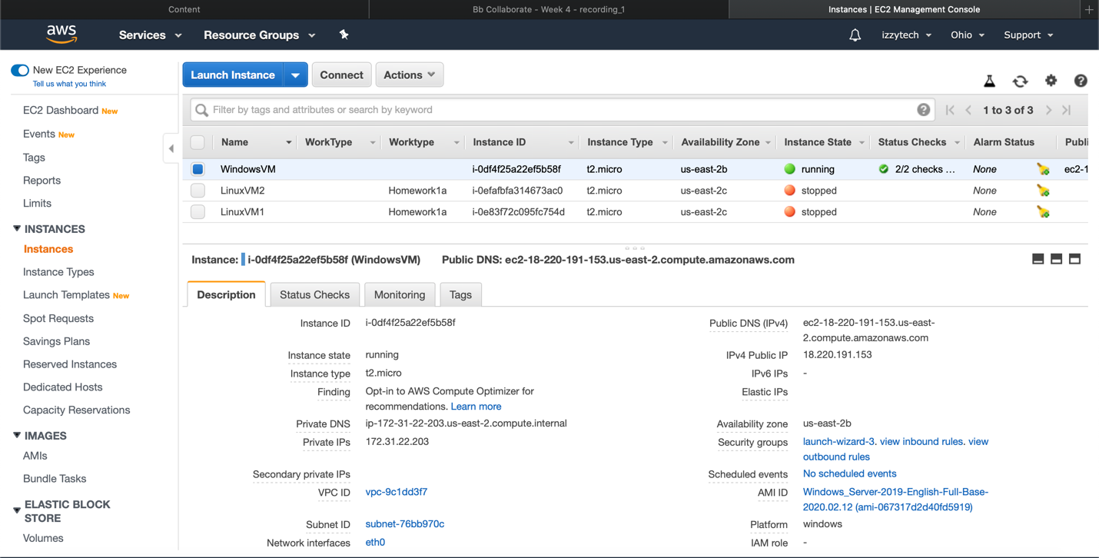

1. The image below shows the “Microsoft Remote Desktop” application with the Windows VM information already registered.

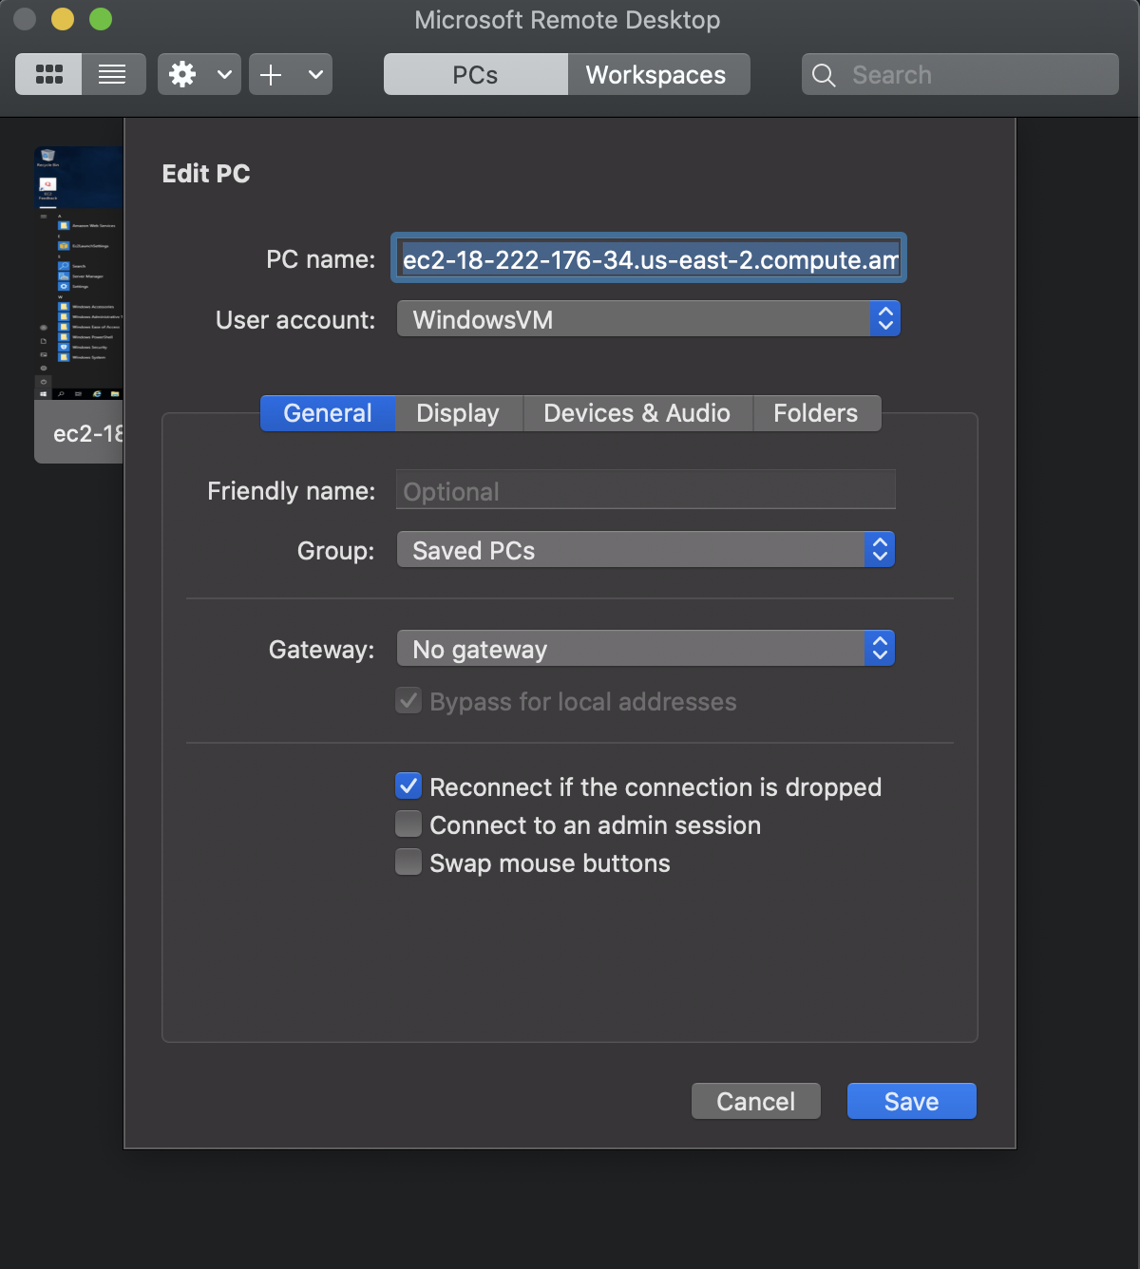

1. Once, we successfully log into our Windows VM. To test out its functionality we are going to downloads AWS CLI so we can then downloads contents from our S3 bucket down to our Windows VM.

1. In case the contents of the S3 buckets were deleted, we are going to again log into our CentOS VM machine, connect to our S3 bucket and upload some files. Again, this step is only necessary in the even the files form the S3 bucket were deleted. Additionally, it is crucial that the CLI keys are activated in order to access our S3 bucket.

1. Finally, having the files existing in our S3 bucket we are going to use “sync” command to download the files from the S3 bucket to our Windows VM. Lastly, we double check the presence of those files in our Windows VM by navigating the file explorer.

